|  |  |  |  |  |
| --- | --- | --- | --- | --- |
|  | Bansilal Ramnath Agarwal Charitable Trust's  Vishwakarma Institute of Information  Technology    **Department of**  **Artificial Intelligence and Data Science** | | | |
| Name: Siddhesh Dilip Khairnar |  | | | |
| Class: TY | Division: B | | | Roll No: 372028 |
| Semester: V | | Academic Year: 2023-2024 | | |
| Subject Name & Code: Image Processing: ADUA31205(B) | | | | |
| Title of Assignment: Perform object detection from an image | | | | |
| Date of Performance: 01-11-2023 | | | Date of Submission: 11-11-2023 | |

**ASSIGNMENT NO. 8**

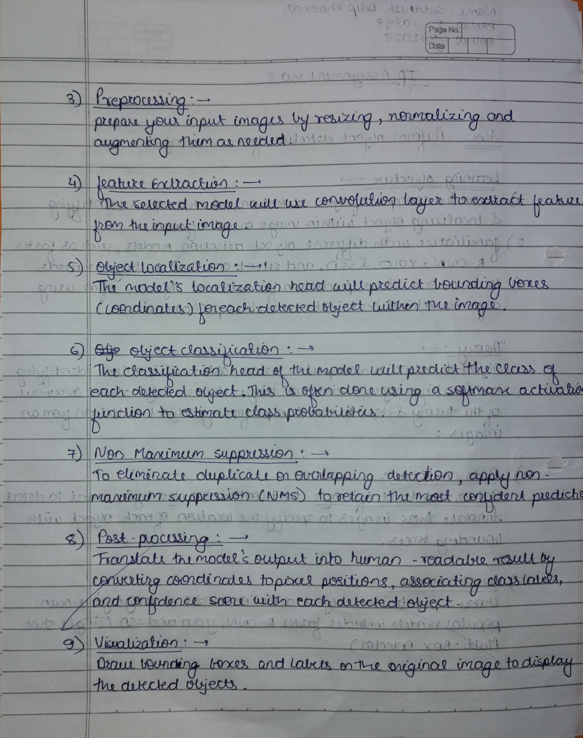

Program Code:

import cv2

from matplotlib import pyplot as plt

import os

# Get the full path to the current script

script_path = os.path.dirname(os.path.abspath(__file__))

# Load Haar cascade file for eyes

cascade_path = os.path.join(

    script_path, "C:/Users/asus/Downloads/haarcascade_eye.xml")

stop_data = cv2.CascadeClassifier(cascade_path)

# Check if the cascade classifier is loaded successfully

if stop_data.empty():

    print(f"Error: Unable to load cascade classifier from {cascade_path}")

    exit()

# Opening image

img = cv2.imread("C:/Users/asus/Downloads/Rahul-Gandhi.webp")

# Convert the image to grayscale

img_gray = cv2.cvtColor(img, cv2.COLOR_BGR2GRAY)

# Detect eyes

found = stop_data.detectMultiScale(img_gray, minSize=(20, 20))

# Display the original image

plt.figure(figsize=(10, 10))

plt.subplot(1, 2, 1)

plt.title('Original Image')

plt.imshow(cv2.cvtColor(img, cv2.COLOR_BGR2RGB))

# Display the image with detected eyes

for (x, y, width, height) in found:

    cv2.rectangle(img, (x, y), (x + width, y + height), (0, 255, 0), 5)

plt.subplot(1, 2, 2)

plt.title('Image with Detected Eyes')

plt.imshow(cv2.cvtColor(img, cv2.COLOR_BGR2RGB))

plt.show()

XML LINK: [haar-cascade-files/haarcascade_eye.xml at master · anaustinbeing/haar-cascade-files (github.com)](https://github.com/anaustinbeing/haar-cascade-files/blob/master/haarcascade_eye.xml)

Output:

